# Web App Design with React Final Project

**Points possible:** 70

|  |  |  |
| --- | --- | --- |
| Category | Criteria | % of Grade |
| Functionality | Does the code work? | 25 |
| Organization | Is the code clean and organized? Proper use of white space, syntax, and consistency are utilized. Names and comments are concise and clear. | 25 |
| Creativity | Student solved the problems presented in the assignment using creativity and out of the box thinking. | 25 |
| Completeness | All requirements of the assignment are complete. | 25 |

**Instructions:** In VS Code, or an IDE of your choice, write the code that accomplishes the objectives listed below. Ensure that the code compiles and runs as directed. Take screenshots of the code and of the running program (make sure to get screenshots of all required functionality) and paste them in this document where instructed below. Create a new repository on GitHub for this week’s assignments and push this document, with your JavaScript project code, to the repository. Add the URL for this week’s repository to this document where instructed and submit this document to your instructor when complete.

**Coding Steps:**

1. Using an online API of your choice, or multiple APIs (or if no API can be found, using an array for in-memory storage is okay as well), create a React project of your choice. You will be working on this for the next three weeks.
2. Project must meet the following criteria:
   1. Use React Router and have at least 3 pages
   2. Use React Bootstrap or an alternative styling library
   3. Contain at least 10 components
   4. Allow for all CRUD operations

**Screenshots of Code:**

**Index.html**

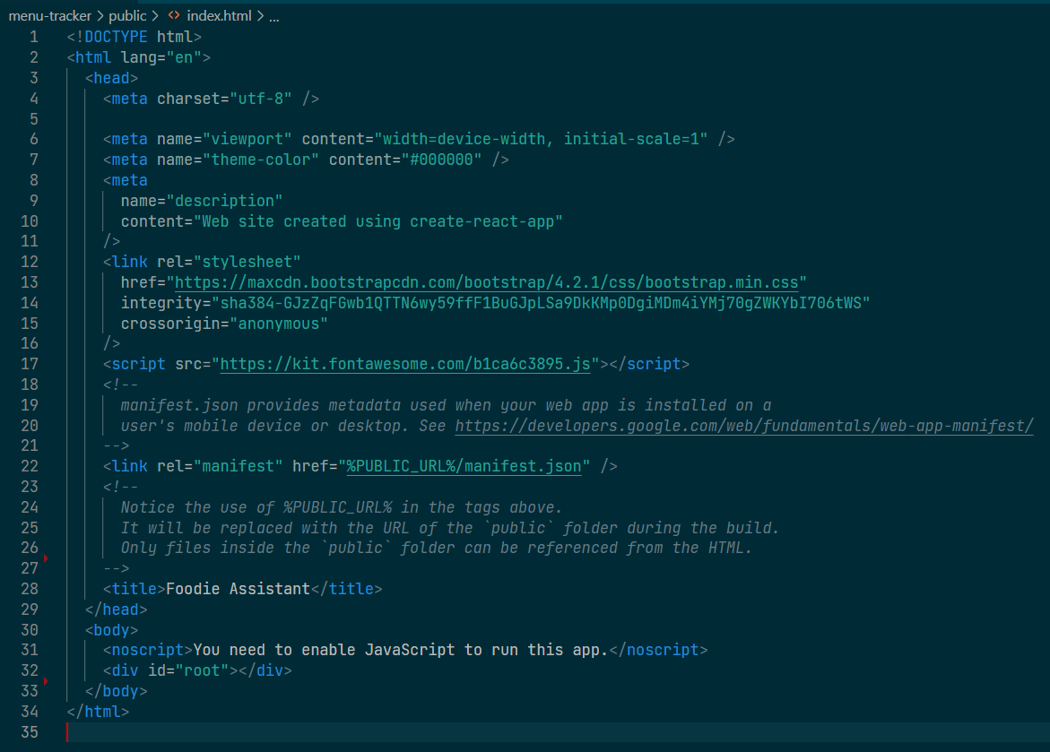

**Index.js**

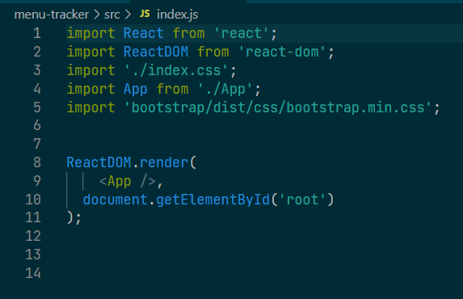

**Index.css**

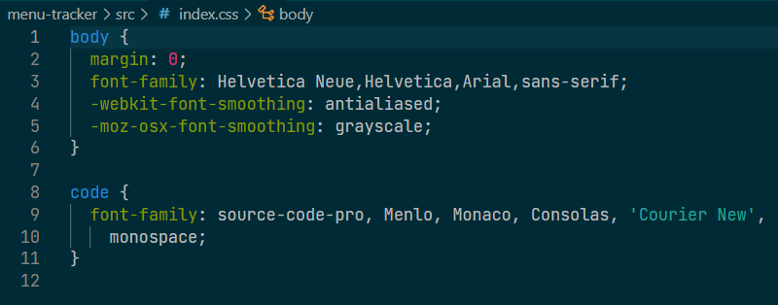

**App.js**

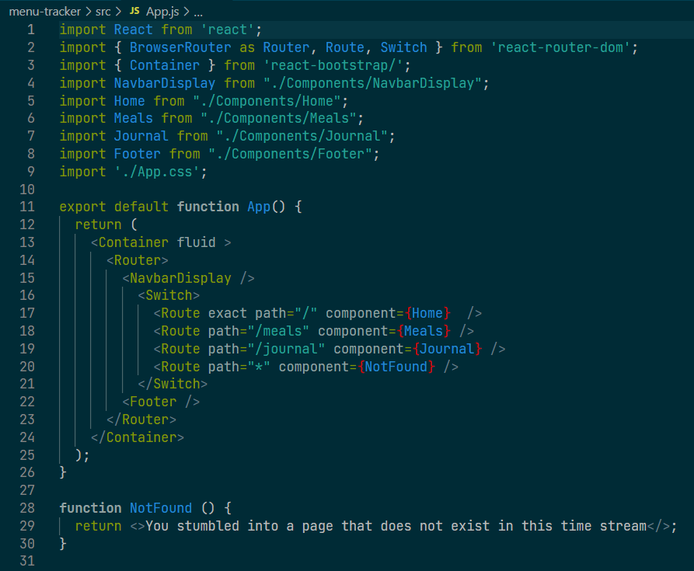

**App.css**

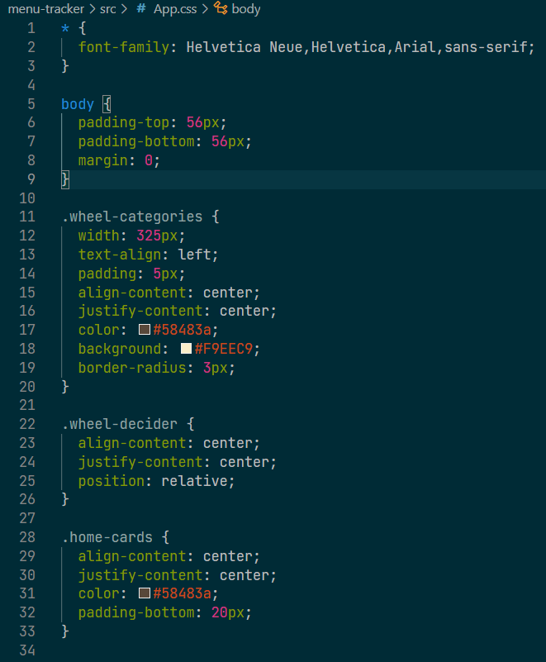

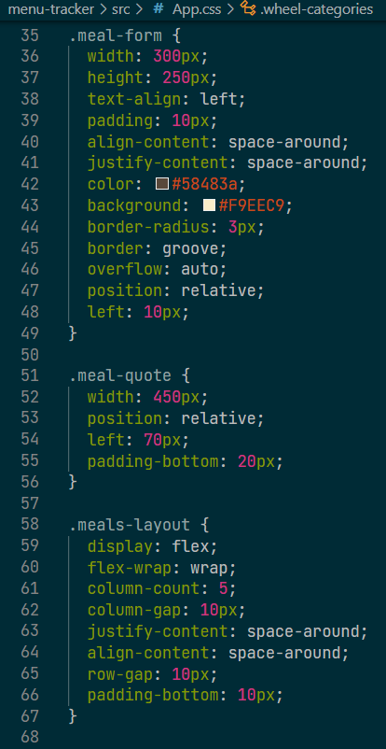

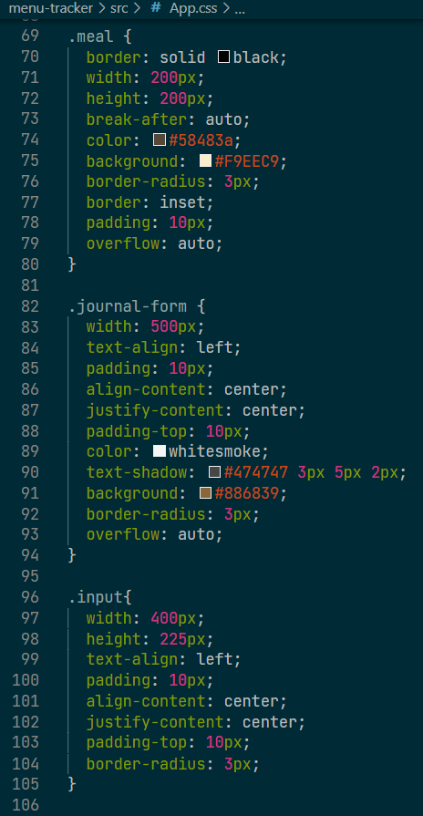

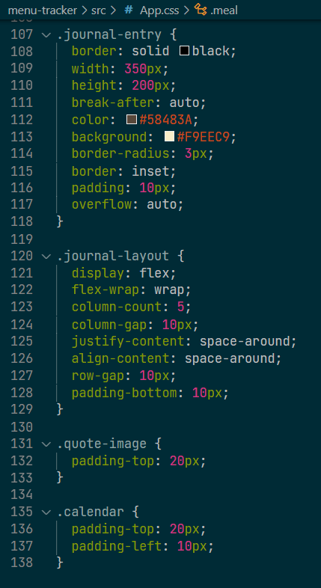

**NavbarDisplay.js**

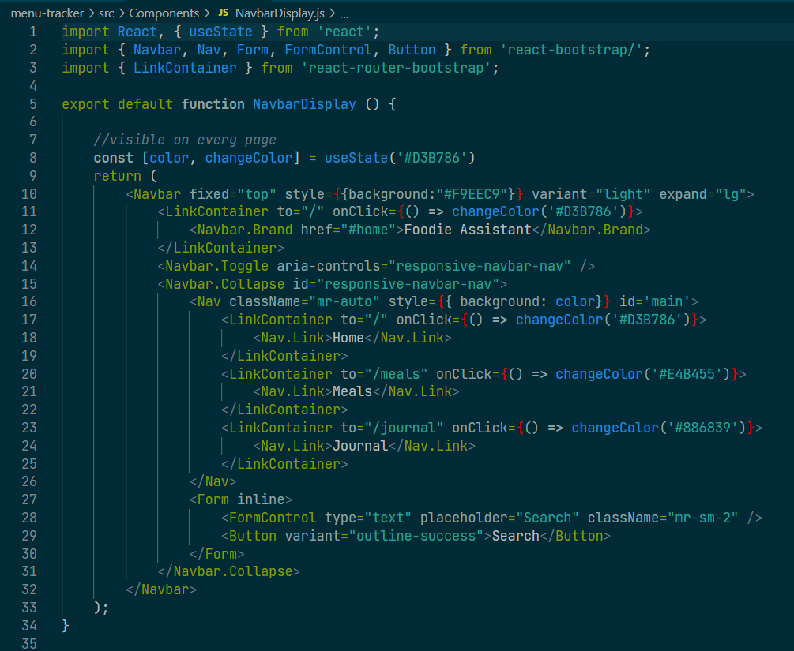

**Home.js**

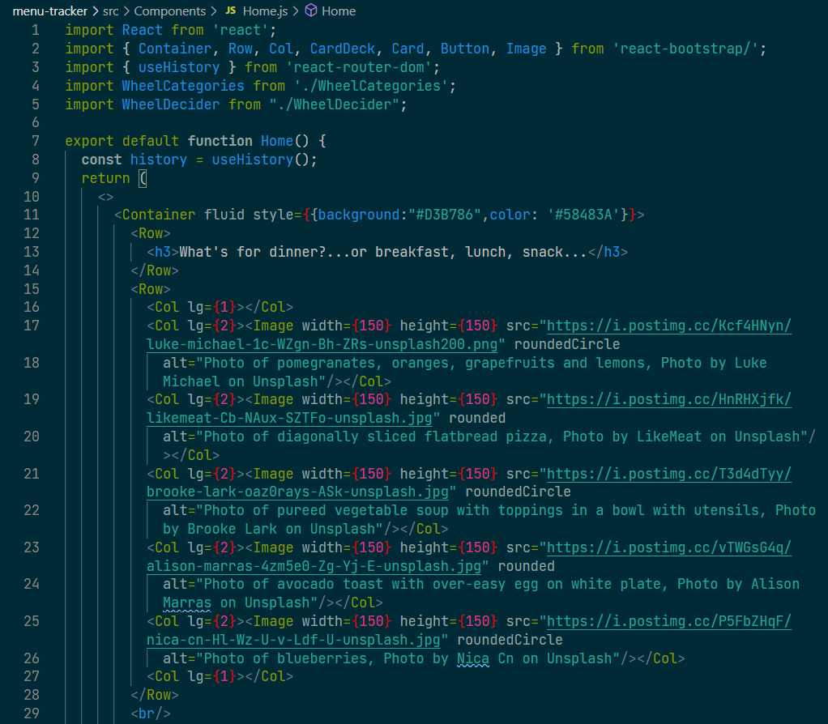

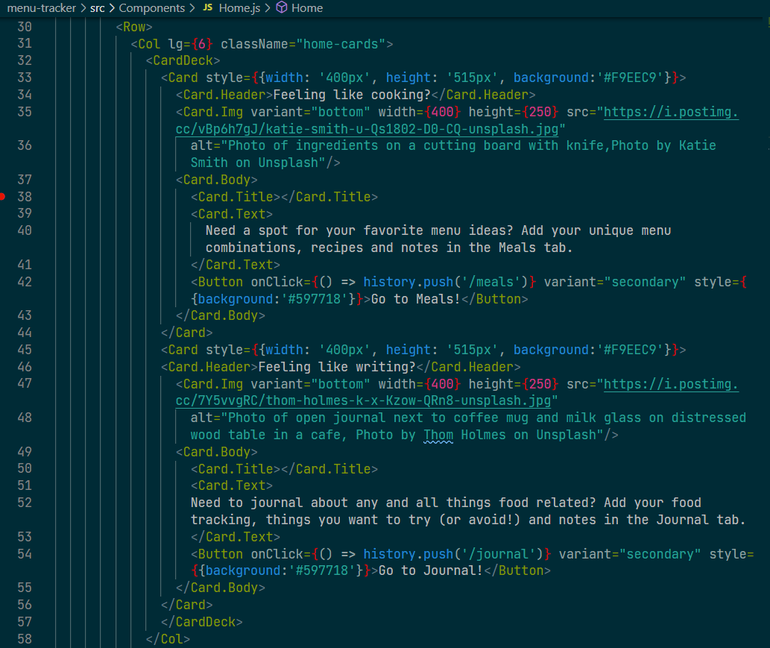

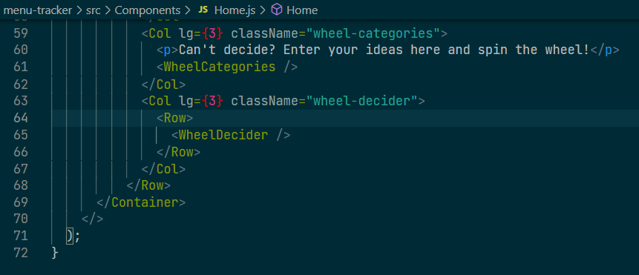

**WheelCategories.js**

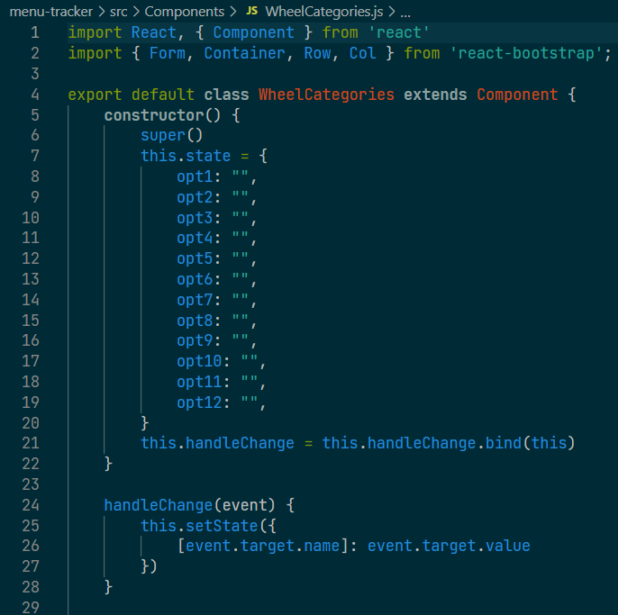

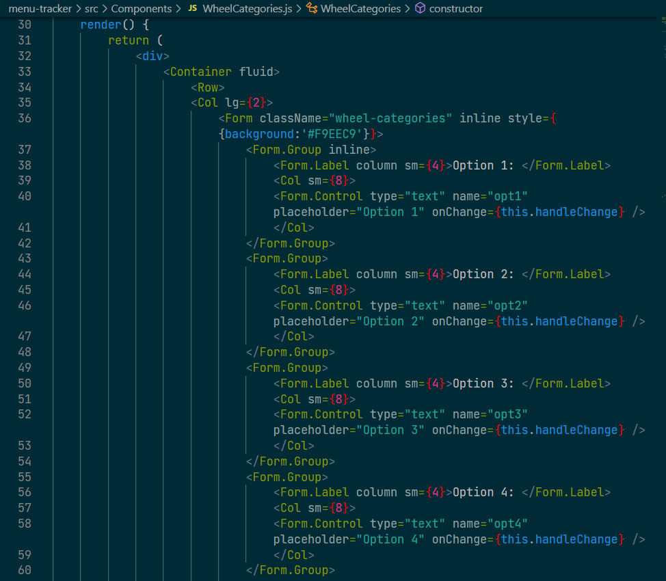

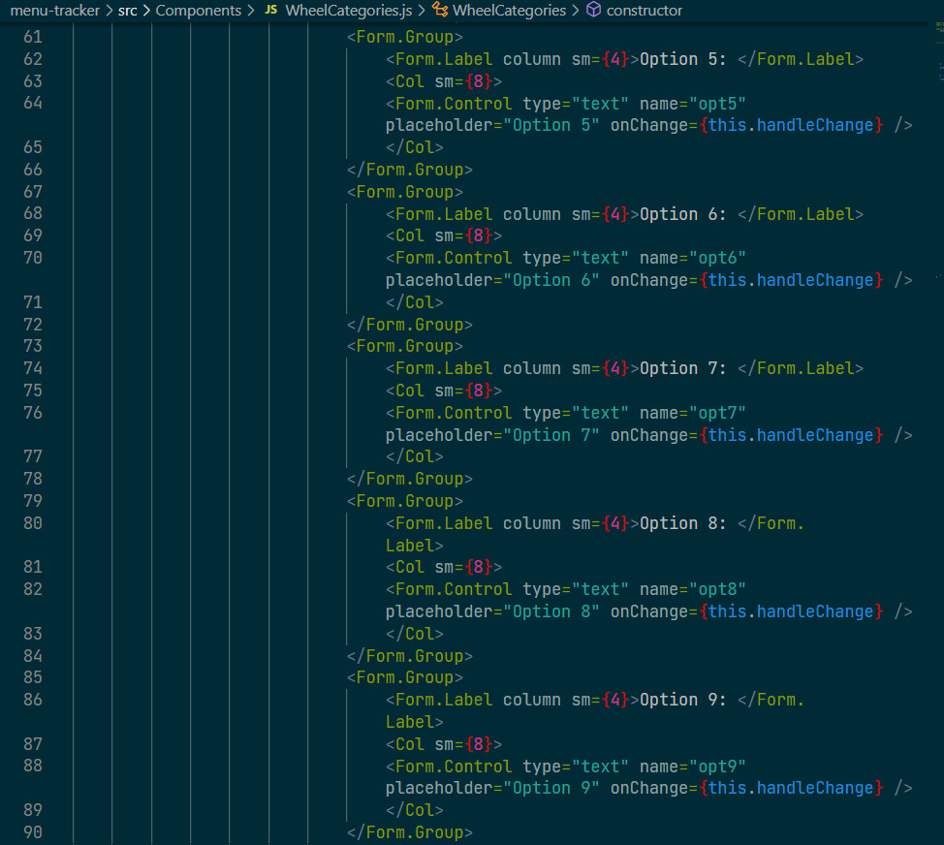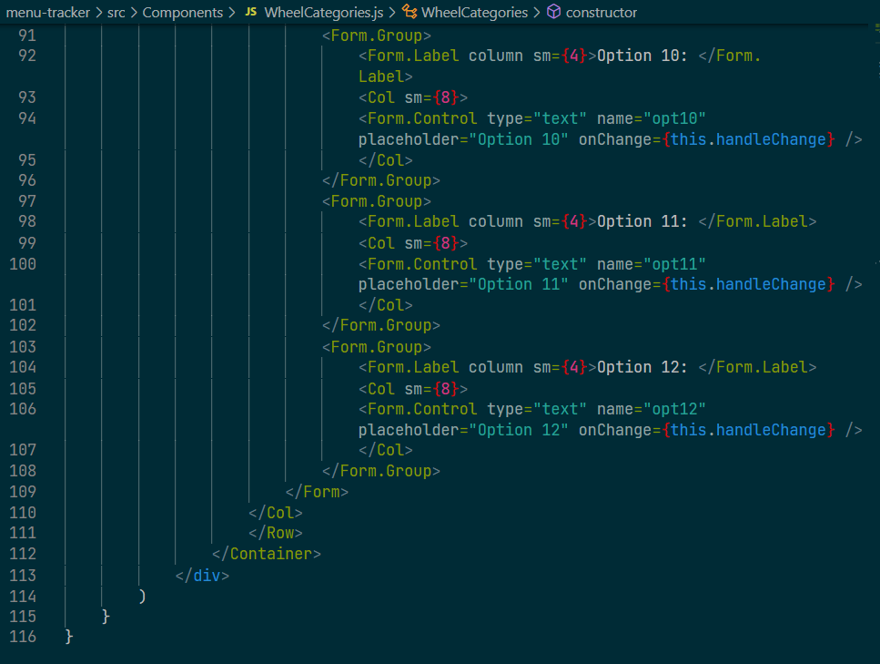

**WheelDecider.js**

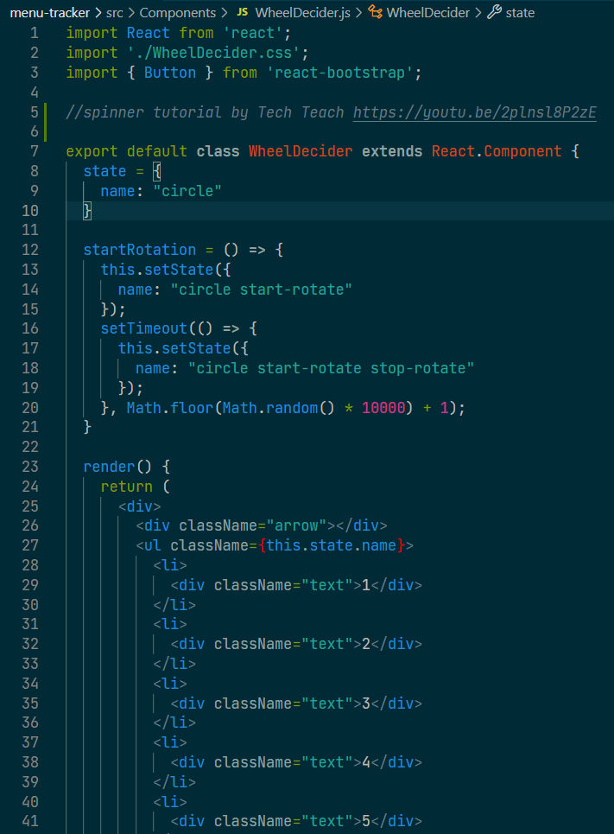

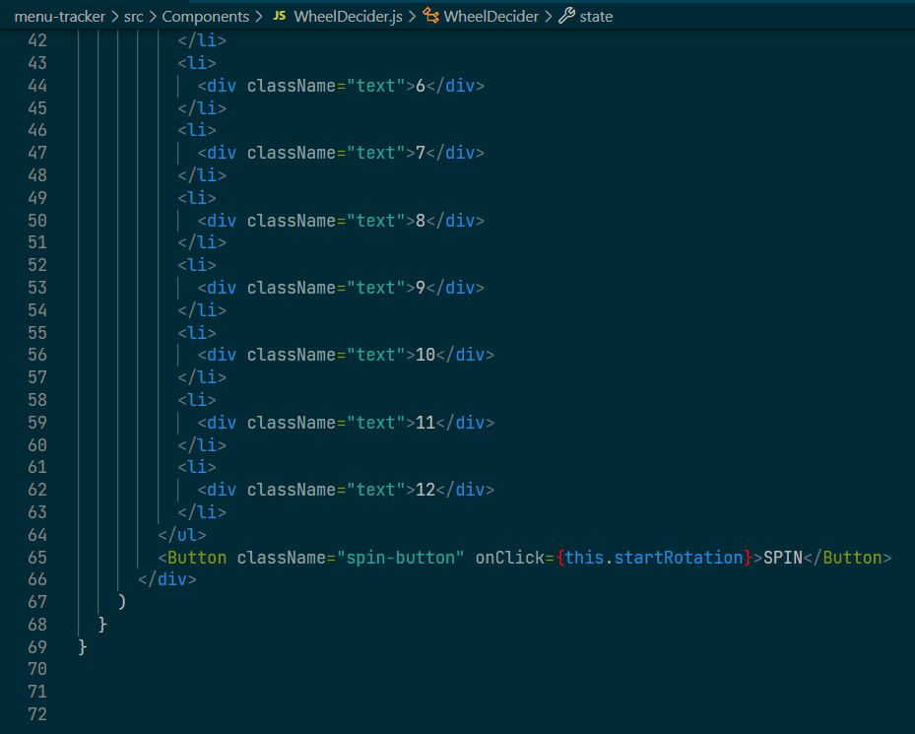

**WheelDecider.css**

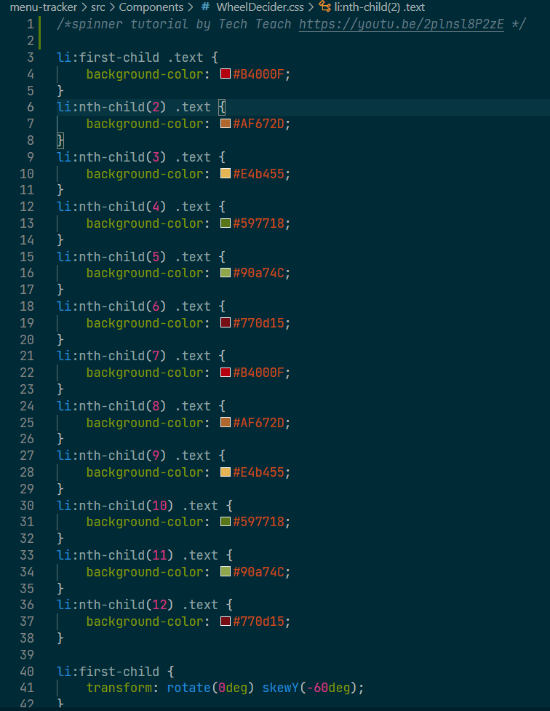

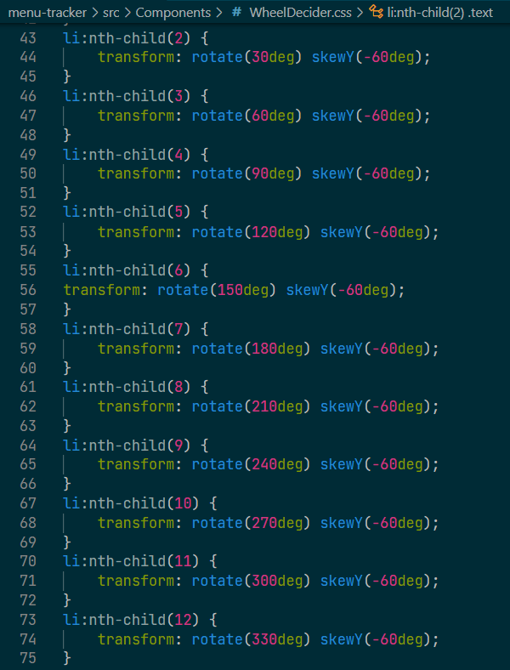

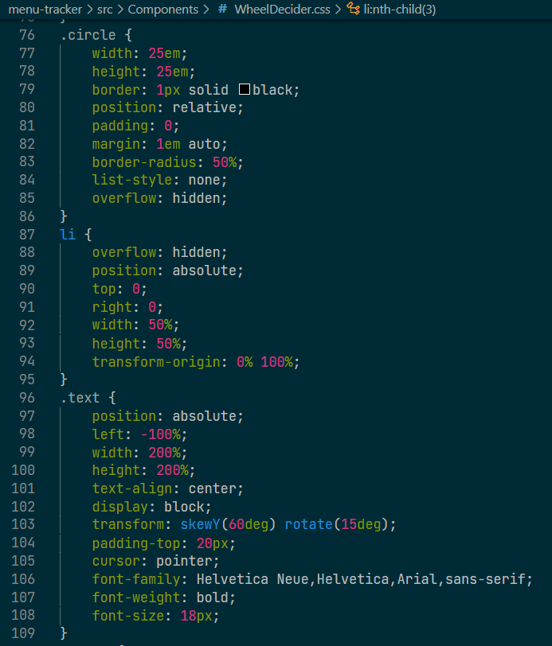

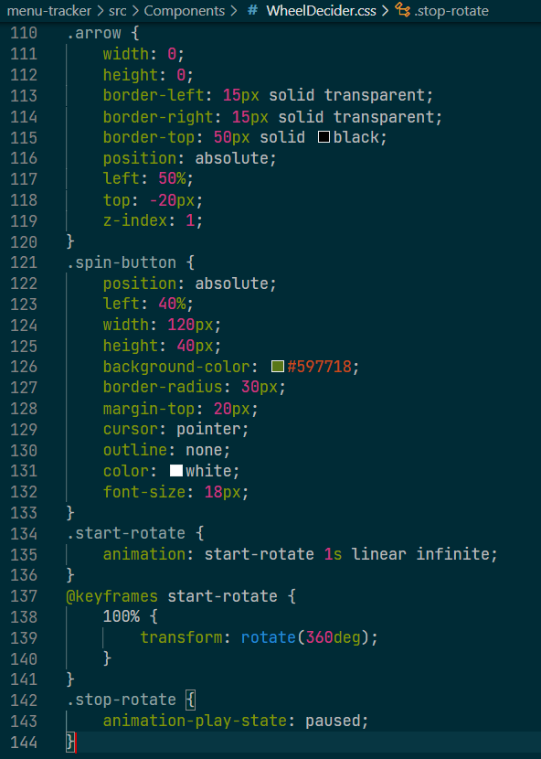

**Meals.js**

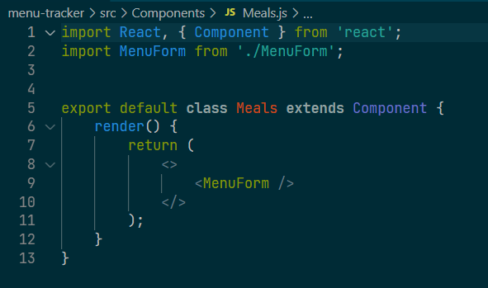

**MenuForm.js**

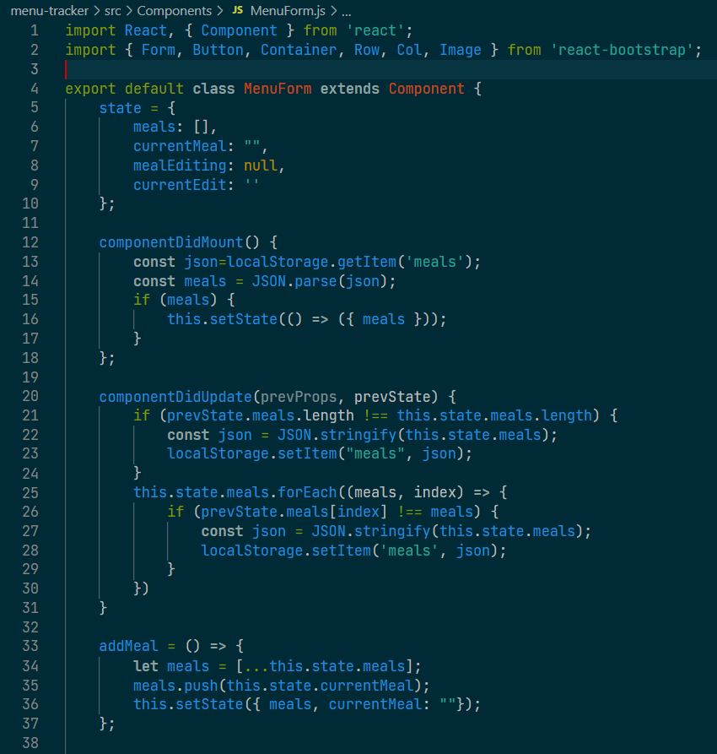

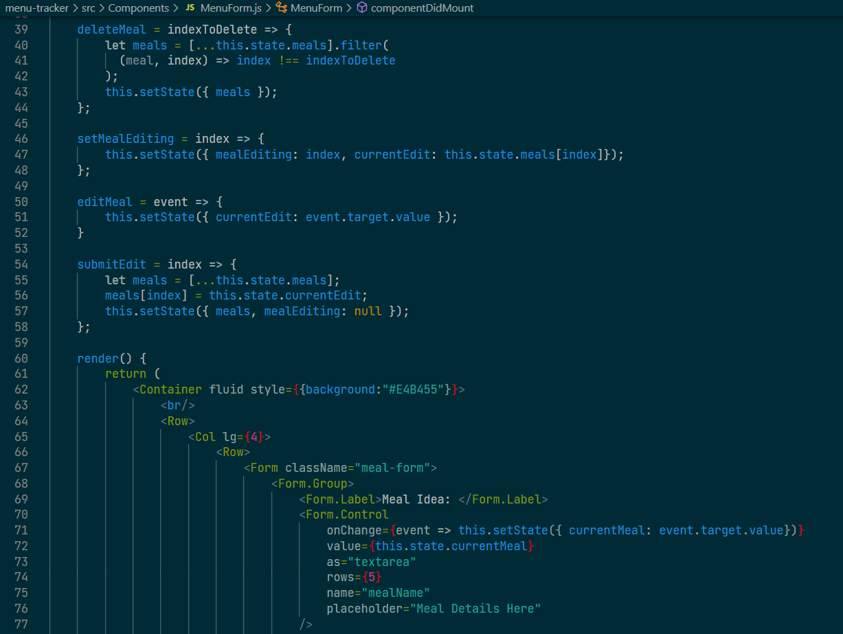

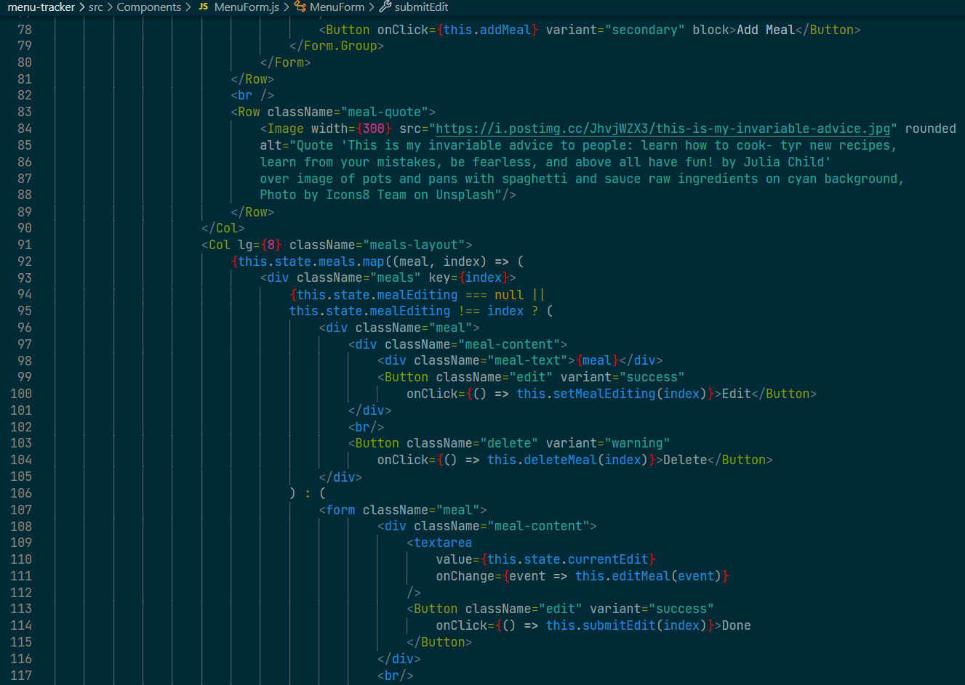

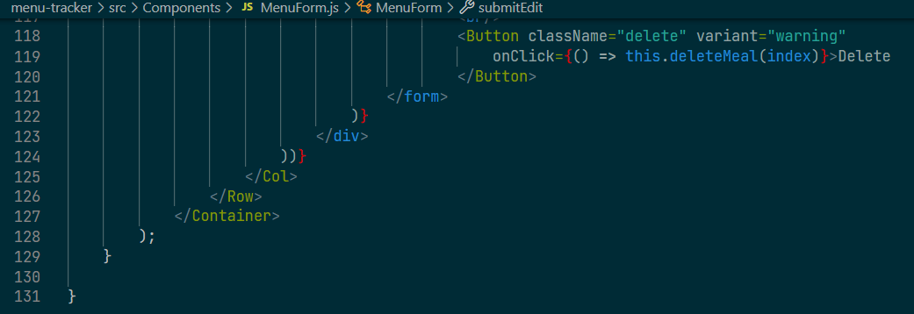

**Journal.js**

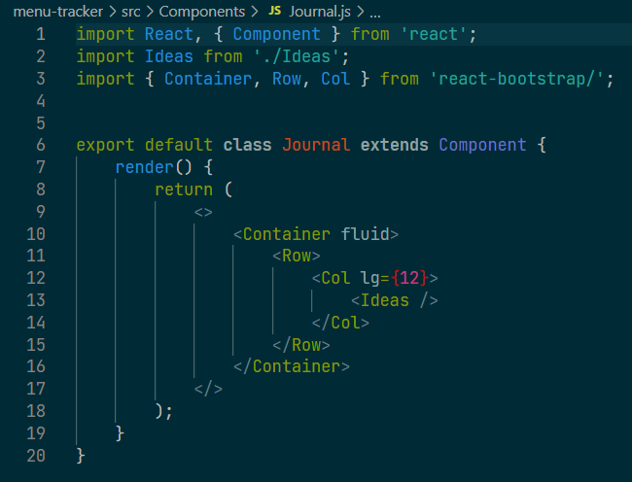

**Ideas.js**

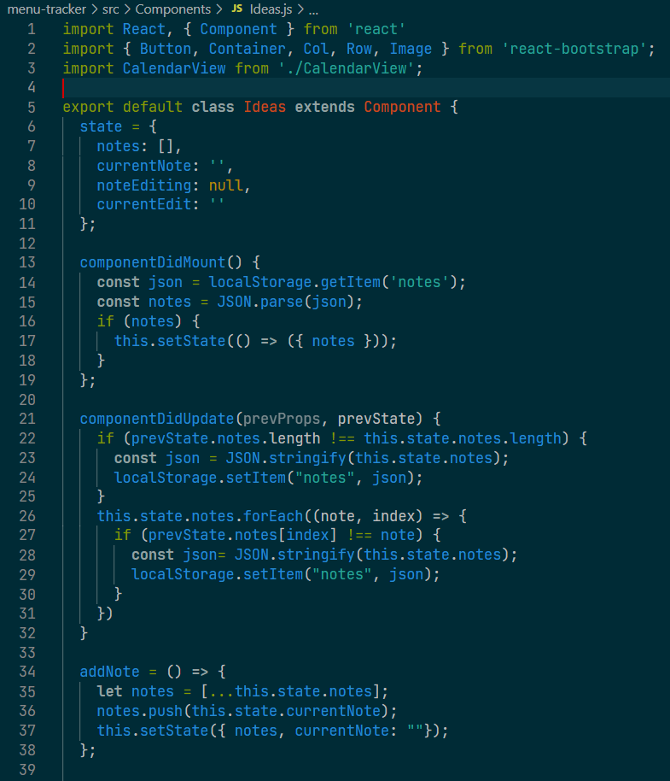

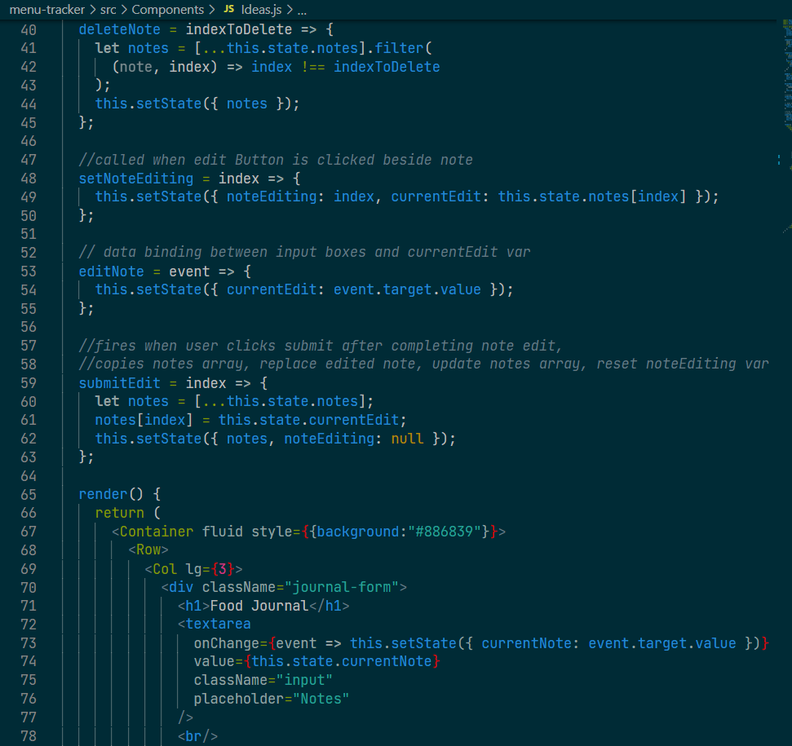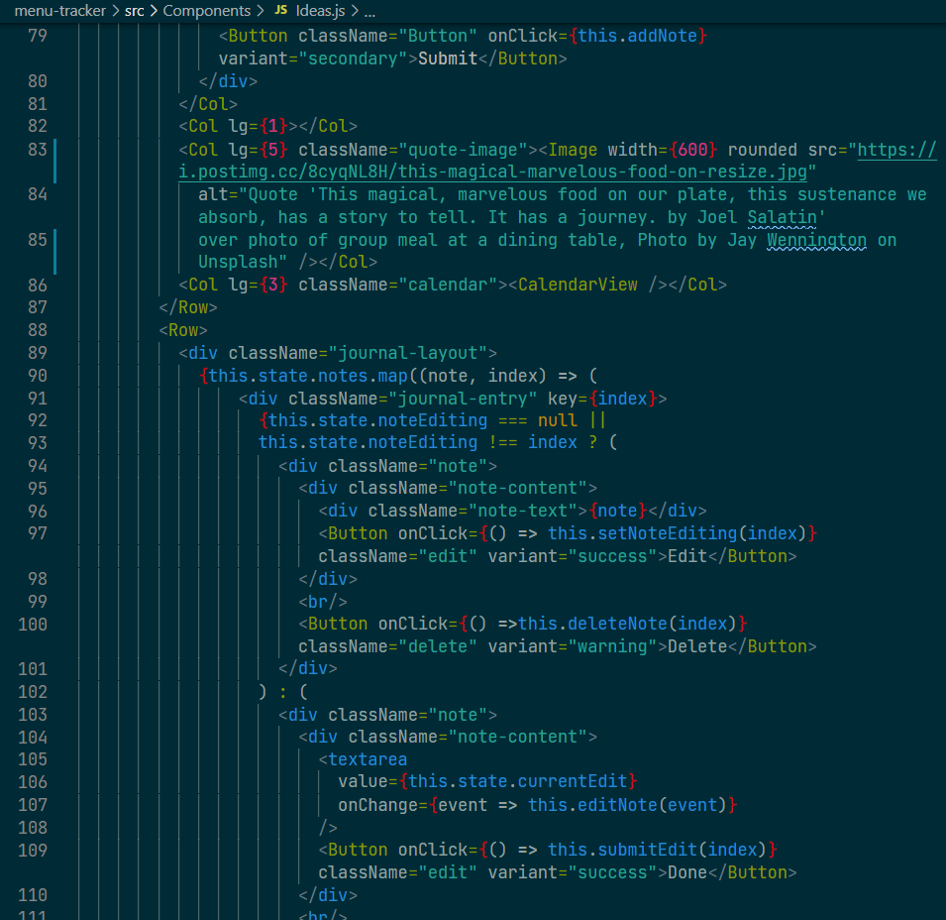

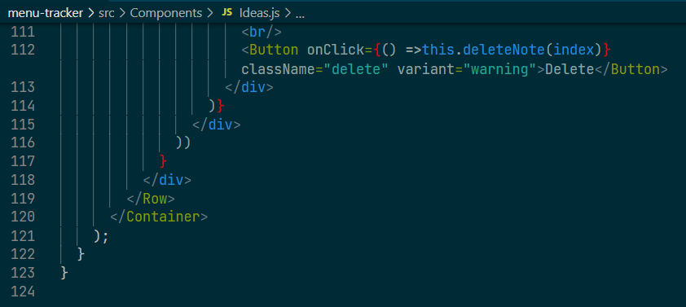

**CalendarView.js**

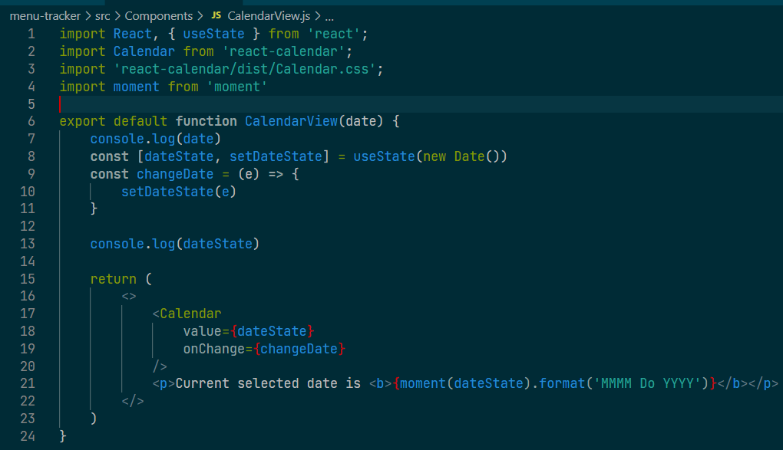

**Footer.js**

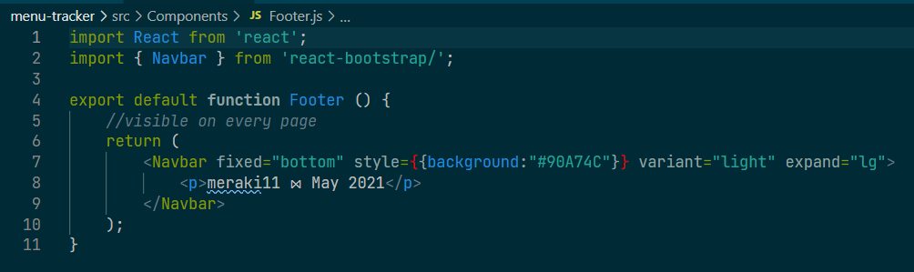

**Screenshots of Running Application:**

**Home:**

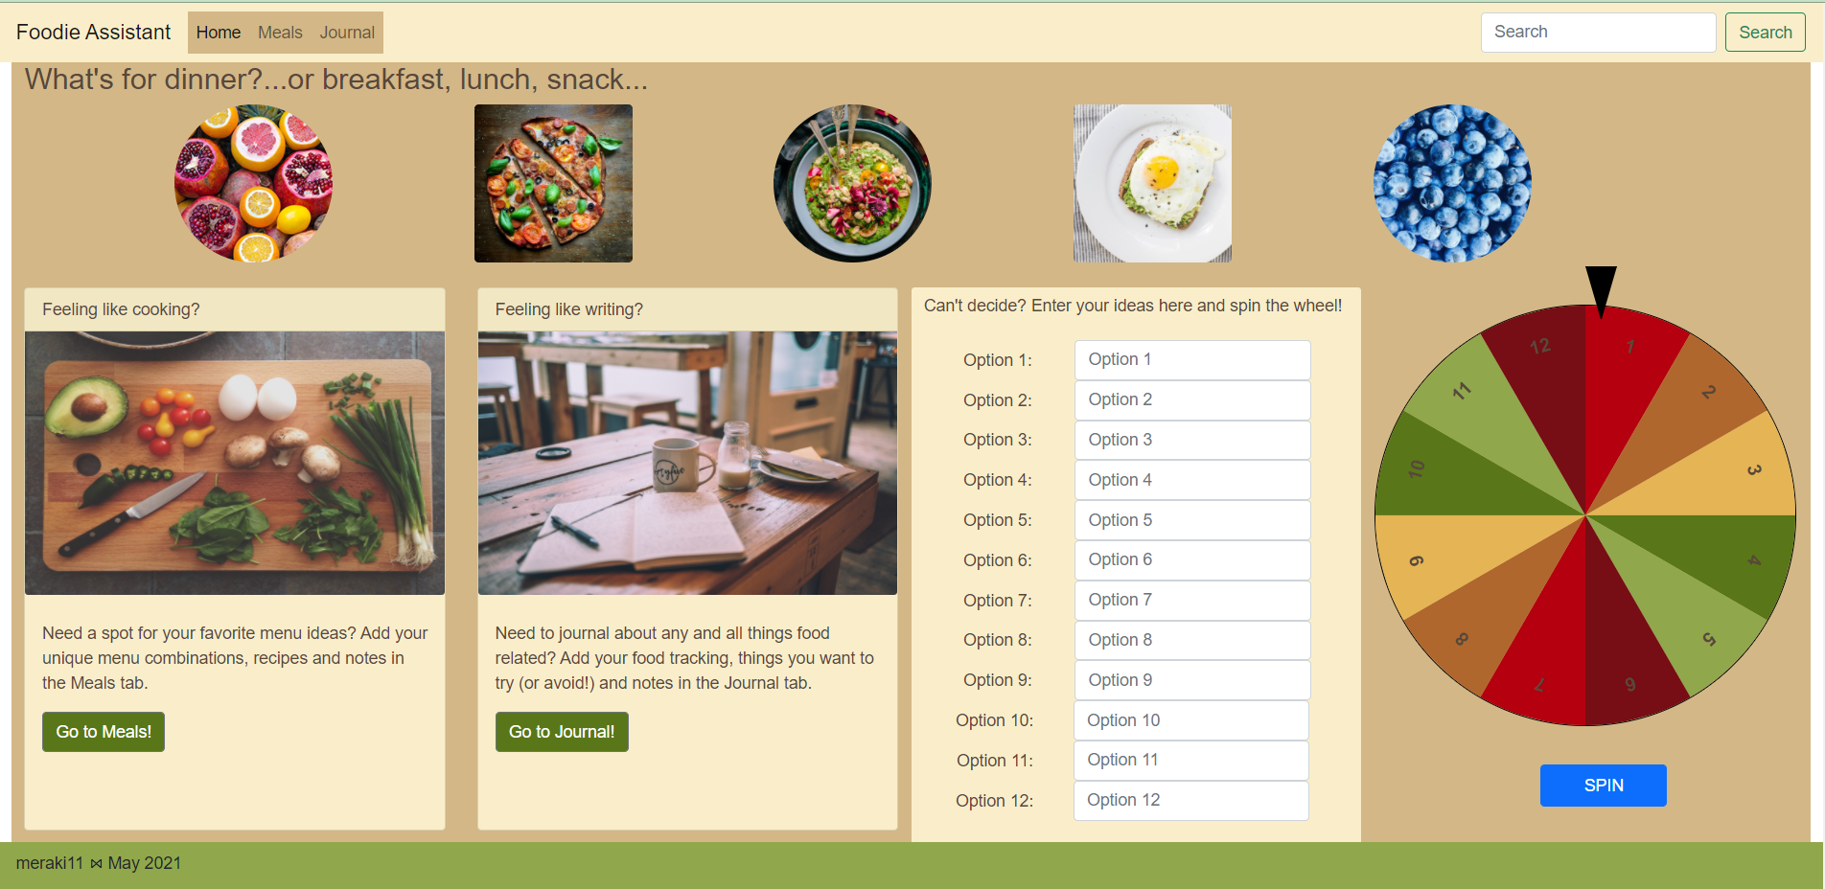

**Enter ideas in option list and spin the wheel:**

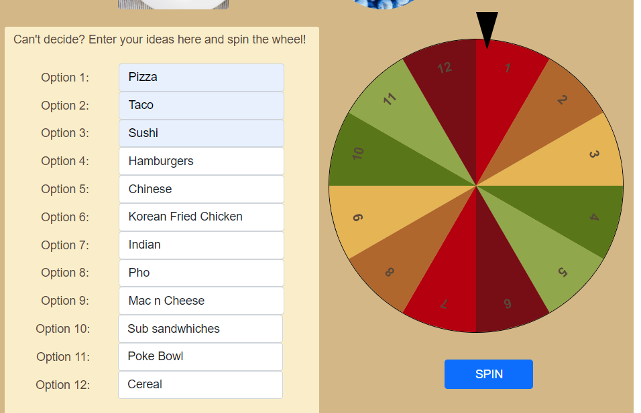

**Spin wheel and Mac n Cheese Wins!**

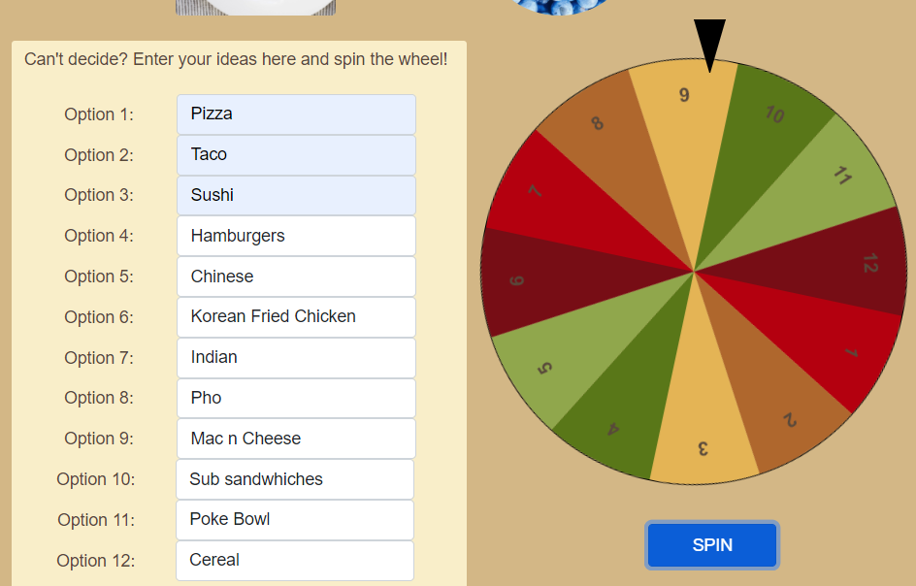

**Click on button on card to go to meals page:**

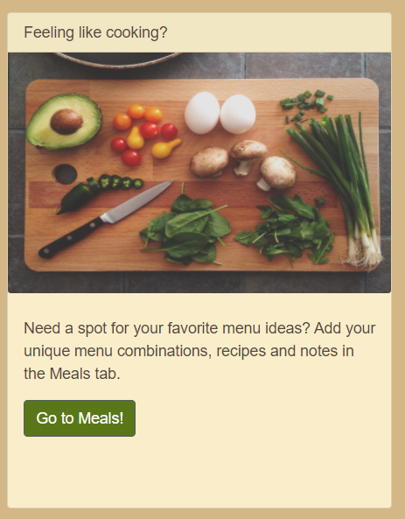

**Meals page:**

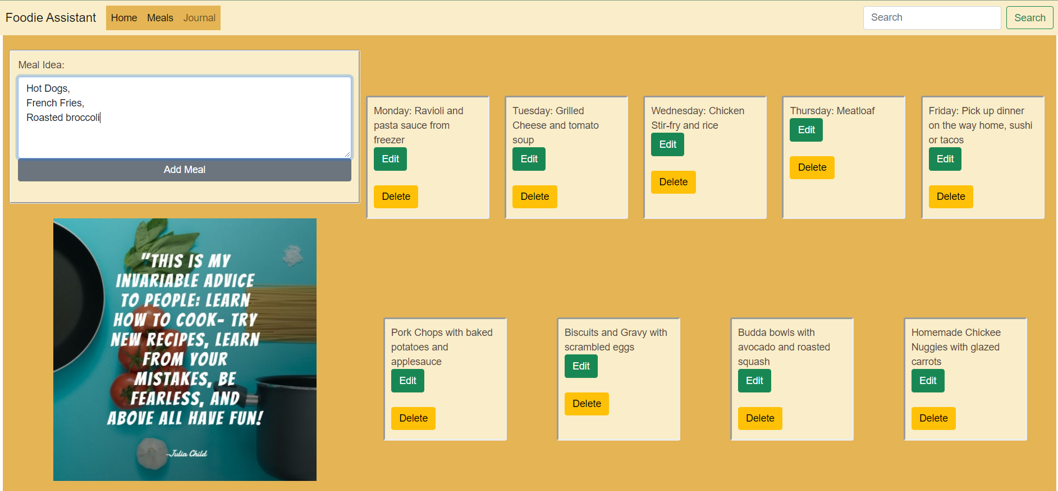

**Add meal idea:**

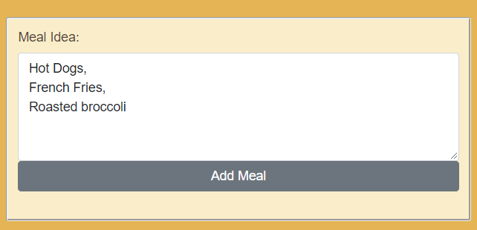

**Adds to meal list:**

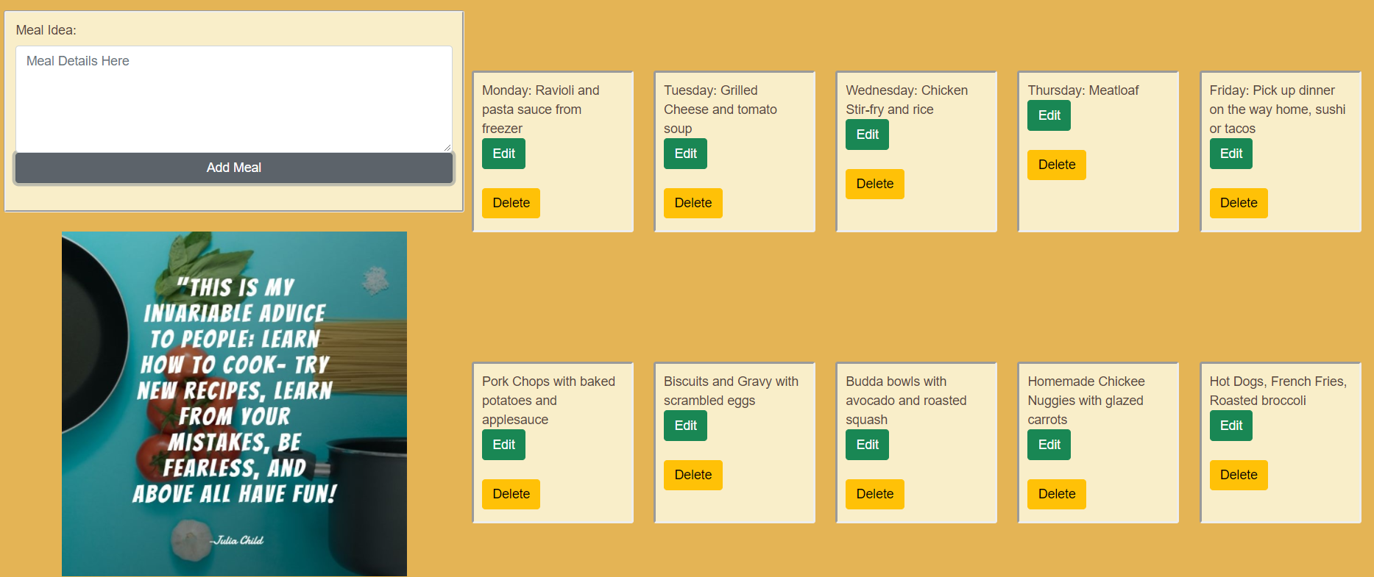

**Edit existing meal idea and click done:**

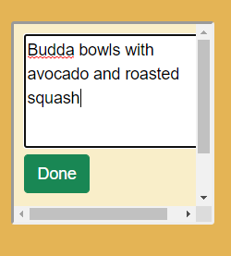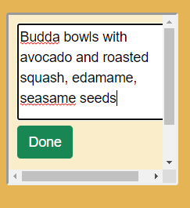

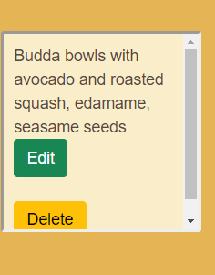

**Delete existing meal idea from list:**

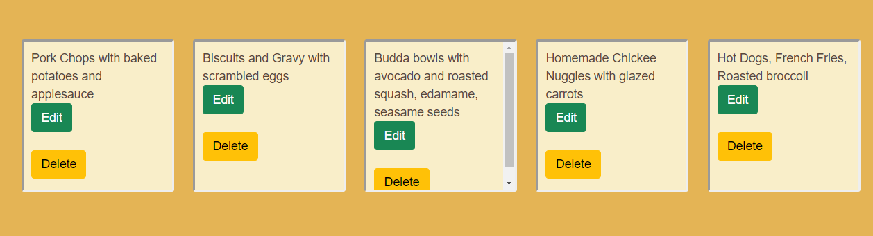

**Meal deleted from list:**

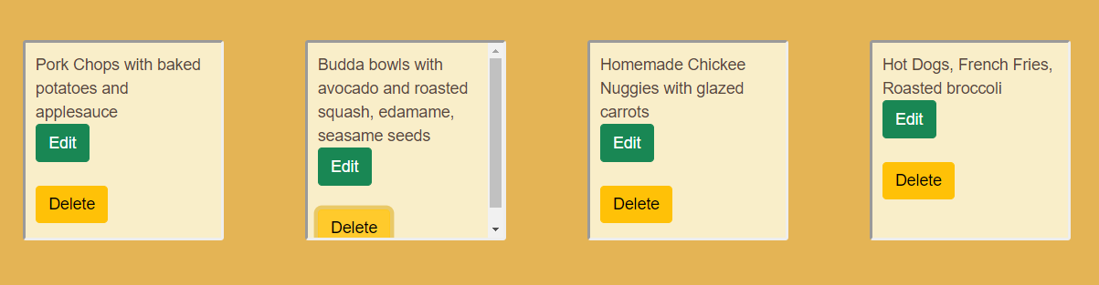

**On Home page, click on button in card for Journal Page:**



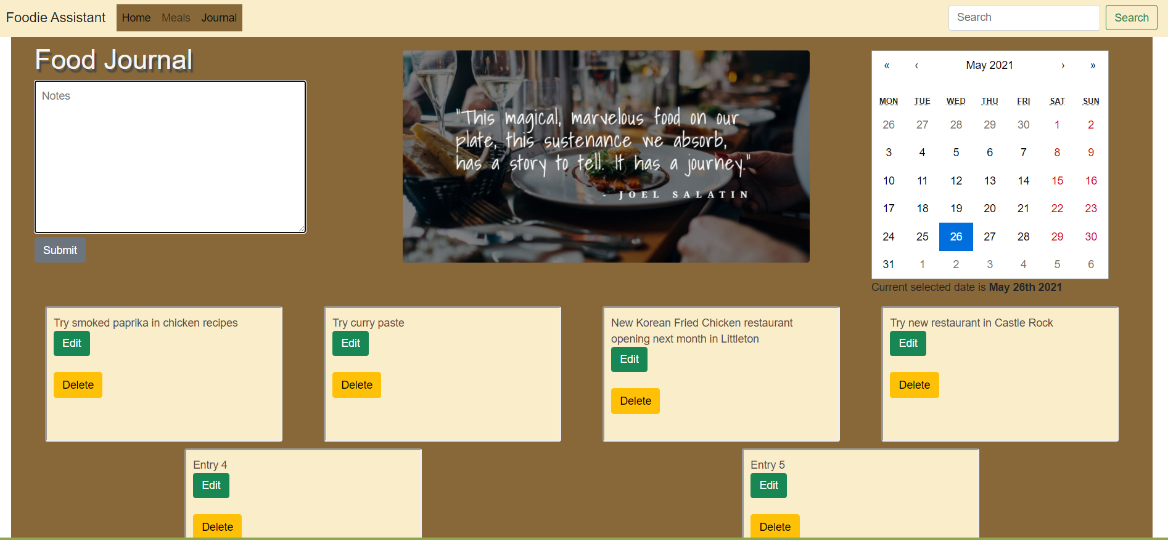

**Add new entry to Journal:**

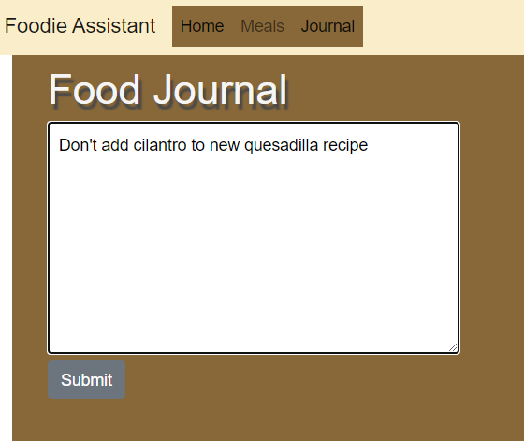

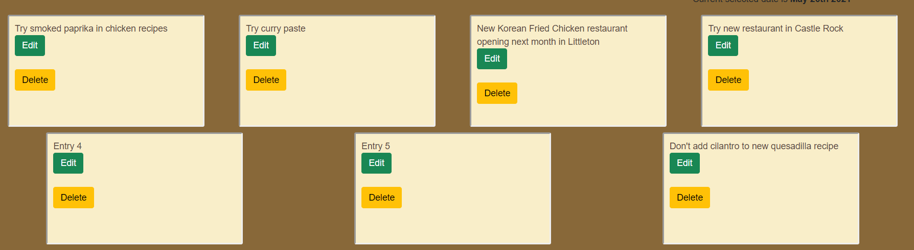

**Edit Entry:**

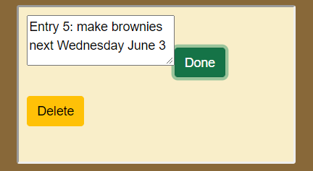

**Delete Entry:**

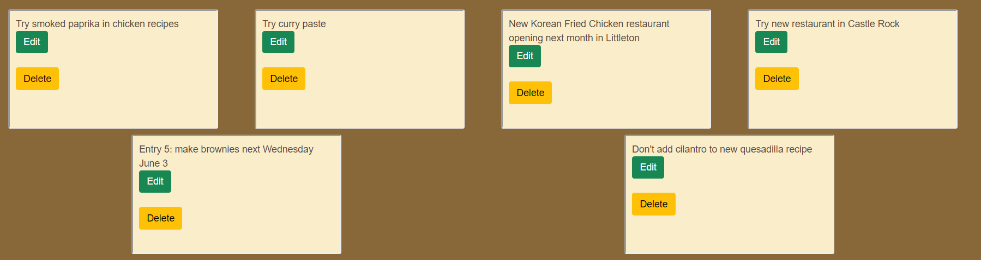

**URL to GitHub Repository:** [**https://github.com/meraki11/menu-tracker.git**](https://github.com/meraki11/menu-tracker.git)

